**Report**



**Learning Outcome 2**

Designing Requirements Specification mobile web application

Contents

Contents 2

Functional Specifications 3

Statement of work 3

Project requirements 4

User requirements and expectations 4

Hardware requirements 5

Software requirements 5

Networking requirements 5

Platform restraints 5

Context of Use 6

Legal requirements 6

Design Specifications 7

Navigation 7

Design aspects for target device 7

Wireframes 8

Colour Theme 10

Typography 10

Design elements 10

# Functional Specifications

## Statement of work

ECinema is a cinema theater company which has requested to produce a mobile web based application to drive reservations sales and inform customers about movies that are showing currently and coming soon. Even though the main product is the reservation, the customers will also be able to check latest offers in food in drink section. The company solicited for a mobile application with professional looking layouts and accessible through a wide range of devices, specially targeted to small screen mobile devices due to usual customer profile. The design and navigation must be modern, progressive and consistent so that the customer does not feel overwhelmed with too many option and increases the customer’s sales loops as they get an habit of doing reservation in this website.

The mobile web application will be compatible with all modern browsers, especially for the ones which have mobile versions. Such browsers are:

* All versions Chrome
* All versions Firefox
* All versions Microsoft edge
* Versions 11+ Microsoft Internet explorer
* Versions 9.1+ Safari
* All versions Opera

It will be possible to register and login to view the showing now movies, upcoming movies, reviews watched movies and do reservations. The users can logout to finish the session and protect their personal details.

The payment methods will be provided by a third-party API payment provided by paypal. This payment API will process all the online reservation payments.

A launch icon will also be produced so that users have it in the mobile phone screens can identify and execute the application.

## Project requirements

The following is required:

* Process online payments
* User Sessions, including register, login and logout functionalities
* Online cart
* Booking system
* Launch icon
* Movie review system
* Home page
* Movie list
* Food and Drink page
* Reservation page

## User requirements and expectations

The user expects and requires:

* User Session: users will be able to initiate their sessions to do movie reservations, do payments and comment on movies moreover finishing sessions after their activity.
* Mobile first: users expect the web application to run on the mobile phone and the design used was developed to be mobile first.
* Performance: using webpack, the developer will produce the website with only the resources necessary, decreasing the loading time.
* User Forms: will allow users to register, login, logout and comment movies.
* Payments: Users will be able to use Paypal payment system which will allow the user to choose from a variety of payment methods.
* Information about movies, future movies plus their offers.
* Food and Drinks menu where different types of snack will be shown.
* Design: The web application, using the UiKit framework, will be visually appealing and easy to use.
* Call to action: this technique will be used throughout the application to give clear intent to the user about which action to take next, avoiding overwhelm the user with too many options.

## Hardware requirements

To access the application the users must have any of the following devices:

* Desktop
* Tablet
* Laptop
* Mobile

## Software requirements

The software required to run the web application is a web browser.

## Networking requirements

To access this web-based application, the user must have internet access either local or remote. The internet connections supported are:

* 3G remote connection
* 4G remote Connection
* WiFi local connection
* Ethernet connection (desktop, laptops)

## Platform restraints

The web application can run on android, Ios, windows phone, windows, macOS and linux operating systems.

## Context of Use

This web application will be informative and well as e-commerce. The administrators will manage the web application content regularly.

## Legal requirements

The web application must adhere to Data protection legislation to secure personal data. Furthermore, the Equality act must also be highly considered in the web application design to allow access to people with any disability.

# Design Specifications

## Navigation

The navigation is intuitive because of the graphical elements which guide the user through the website. The addition of landing page is to give an introduction to the user about what the cinema has to offer and how the web application works.

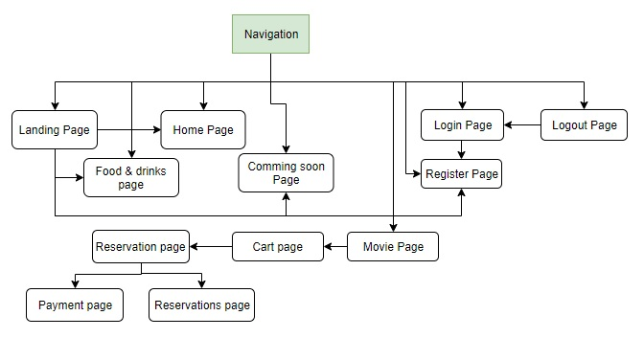

## Design aspects for target device

The mobile web-based application was designed to be mobile first type of design. This means the application supports all screen sizes and resolutions from extra small mobile phones to large tables. This design also extends to many desktop sizes from small desktop screens to extra-large screens. To accomplish these goals, I am using UiKit 3 framework together with webpack. Uikit framework, is a lightweight and modular frontend for developing web interfaces.

This framework also brings flexbox which automatically positions block elements on free space, centering them both on height and width.

The framework that is being used has pre-compiled es6 version JavaScript (without any extra library) and SCSS which compiles into CSS. Webpack is the tool used to manage and compile all JavaScript and SCSS assets into single bundles of JavaScript and CSS. SCSS is compiled into CSS using Style-loader, Css-loader and Scss-loader Webpack plugins. The pre-compiled es6 JavaScript code not supported by most browsers is compiled down to es5 using Babel Javascript compiler, supported in Webpack trough a plugin. By compiling the JavaScript down to es5, it grants the web app cross-browser compatibility.

The JavaScript compilation goal is, besides compatibility, to only compile components used in the applications excluding all non-used components. The SCSS compilation goal is to compile only the used components but also to modify variables before the SCSS files are compiled, which will allow me to change the colour variables to instantly create new colour themes.

The end goal of webpack is manage web application resources, using external plugins, to improve performance and lower bandwidth necessary to run applications.

## Wireframes

Mobile

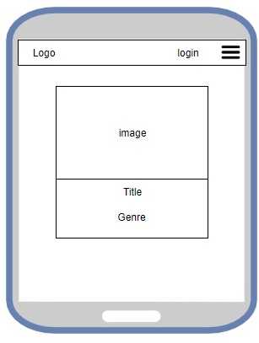

Tablet

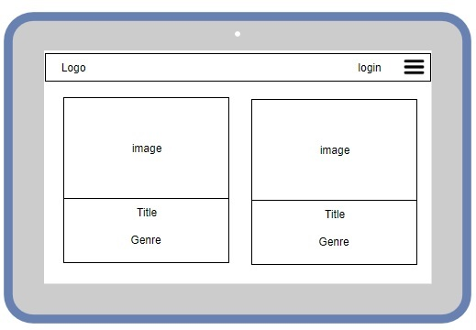

Desktop

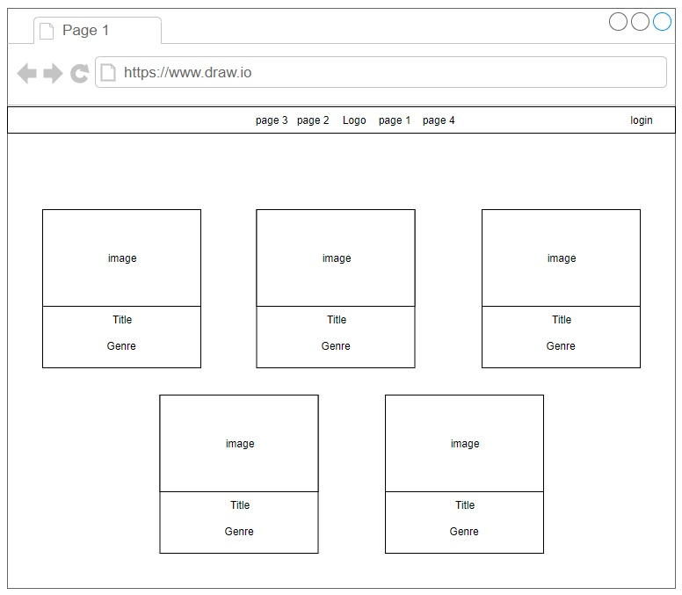

## Colour Theme

There is an effective use of colour thanks to the front-end framework and Scss which uses variables through the framework and allows to effectively change the theme of the website. The colour pallet was chosen to be dominantly dark, hence the cinema environment. The purple and blue colours give the user an mystery and excitement feelings. This theme aims to match the cinema’s environment and appeal to users who are looking for and fun and exciting experiences.

Hexadecimal Colours code:

* primary colour: #3A14C5
* secondary colour: #A239CA
* dark colour: #0E0B16
* light colour: #E7DFDD

## Typography

The typography type used in this website is sans-serif due to the modern, progressive and consistent design required by the client. The fonts used are UiKit built-in fonts, which can change depending on the platform or browser, hence the mobile web-based application’s cross-platform and cross-browser nature. The fonts used are:

* Arial
* Helvetica Neue
* ProximaNova
* Roboto
* Segoe UI

## Design elements

The design features used are:

* Mobile navbar
* Modal movie
* Lightbox
* Lightbox gallery
* Image Gallery
* Accordion
* Navbar
* Breadcrumbs
* Youtube iframes
* Parallax elements
* Scroll Animation
* Background video
* Background image parallax

UIkit framework also offers built-in vector icons.

The icons used are:

* Sign in:
* Sign out:
* Menu:
* Comment:
* Cart: 
* Payment:
* Delete:
* Play: 
* Accordion: 